PRESENTING CLINICAL SIGNS
History: Weight loss past 2 months, eating less since hurting right CCL.
Physical Examination: N/A.
Urinalysis: Hematuria with UTI.
CBC: Mild anemia, thrombocytopenia.
Serum Biochemistry: N/A.
Radiographic Findings: N/A.

ULTRASONOGRAPHIC EXAMINATION OF THE ABDOMEN
Urinary System
Full urinary bladder with a normal thickness and appearance of the wall. Moderate amount of floating hyperechogenic sediment present. No uroliths evident.
Normal trigone area, proximal urethra (0.6 cm), and iliac blood vessels.
Iliac lymphadenomegaly (left 1 x 3.4 cm, right 0.8 x 3.2 cm) with normal shape and echogenic appearance. Ureters not visualized.
Normal renal size (left 6.3 cm, right 6 cm), echogenic appearance, cortico-medullary differentiation, pelvis, and capsule.
Reproductive System
N/A.
Adrenal Glands
Normal position, echogenic appearance, shape, and size. Left 0.7/0.52 cm, right 0.49/0.69 cm.
Spleen
Normal size and echogenic appearance. Smooth homogenous parenchyma, regular curvilinear capsule, and normal vasculature. Large mottled echogenic irregular cavitatory mass (9.6 x 10 cm) in the tail of the spleen. Small hypoechogenic nodule (1.6 cm) in the head of the spleen.
Liver
Normal size, echogenic appearance, portal markings, and regular curvilinear capsule. No nodules or masses evident.
Gall bladder
Full containing normal anechoic bile. Normal thickness and echogenic appearance of the wall. Normal bile duct (0.2 cm).

Gastrointestinal
Normal appearance of the stomach, duodenum, small intestine, ileo-cecal junction, and colon with no loss of layering, normal wall thickness (stomach 0.49 cm, duodenum 0.38 cm, jejunum 0.36 cm) and peristaltic activity, and no distension of the lumen.
Pancreas
Normal size (right 1.2 cm) and echogenic appearance. Regular capsule. Normal echogenic appearance of the mesentery and fat surrounding the pancreas.
Free Abdomen
Mesenteric lymphadenomegaly (0.6 x 5.2 cm) with normal shape and echogenic appearance.
Small amount of ascites present.
Thorax
Normal appearance of the heart.
No pericardial or pleural effusion evident.

ULTRASONOGRAPHIC FINDINGS
Primary Findings:
- Splenic mass and nodule.
- Lymphadenomegaly.
- Ascites.
Secondary Findings:
- Urinary bladder sediment.

INTERPRETATION OF THE FINDINGS & FURTHER RECOMMENDATIONS
The most likely etiology for the splenic mass would be neoplasia and for the splenic nodule, hyperplasia, granuloma, hematoma, organized abscess, and neoplasia.
Etiologies for the lymph nodes would be reactive, lymphadenitis, and infiltrative neoplasia.
The most likely etiology for the ascites would be hemabdomen.
The urinary bladder sediment is in line with the reported UTI.
Further assessment would be urine culture, 3-view thoracic radiographs, FNA cytology of the lymph nodes, and laparotomy, the latter being both diagnostic and therapeutic.
Specific therapy would be dependent on an etiological diagnosis.

IMAGES
Spleen
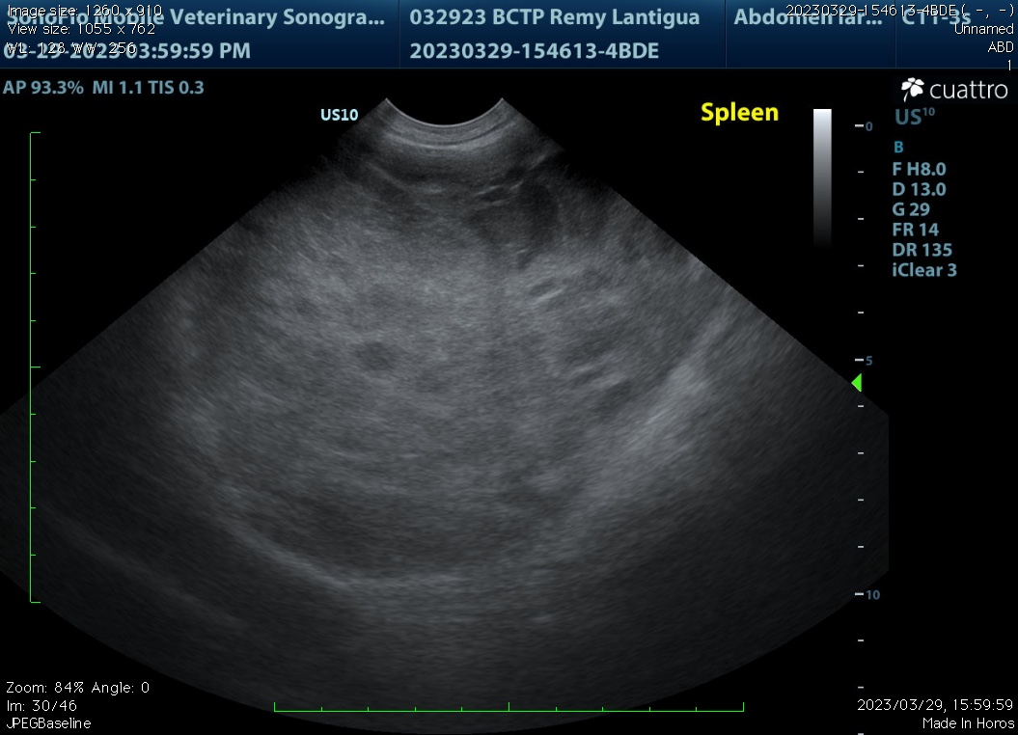
Urinary bladder
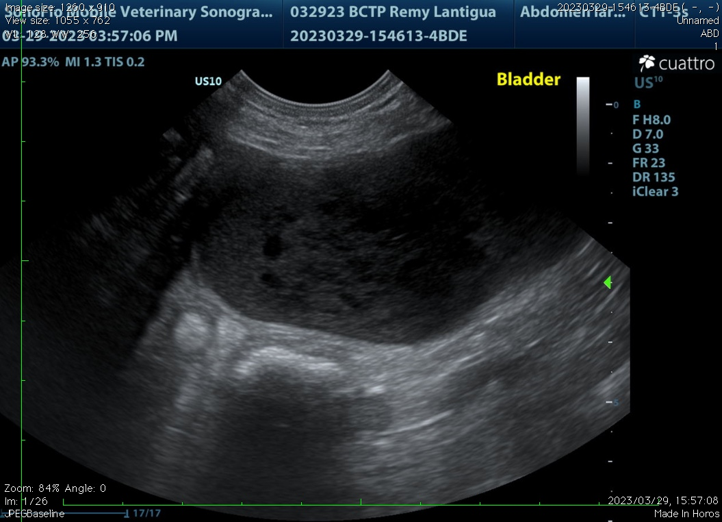

Lymph nodes
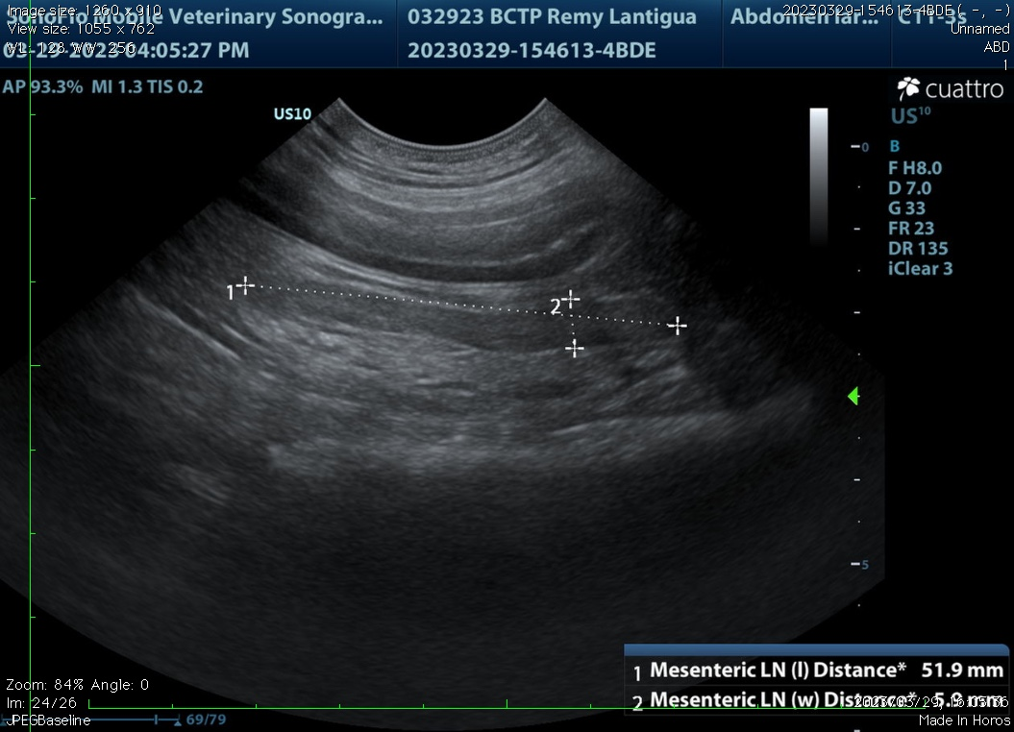
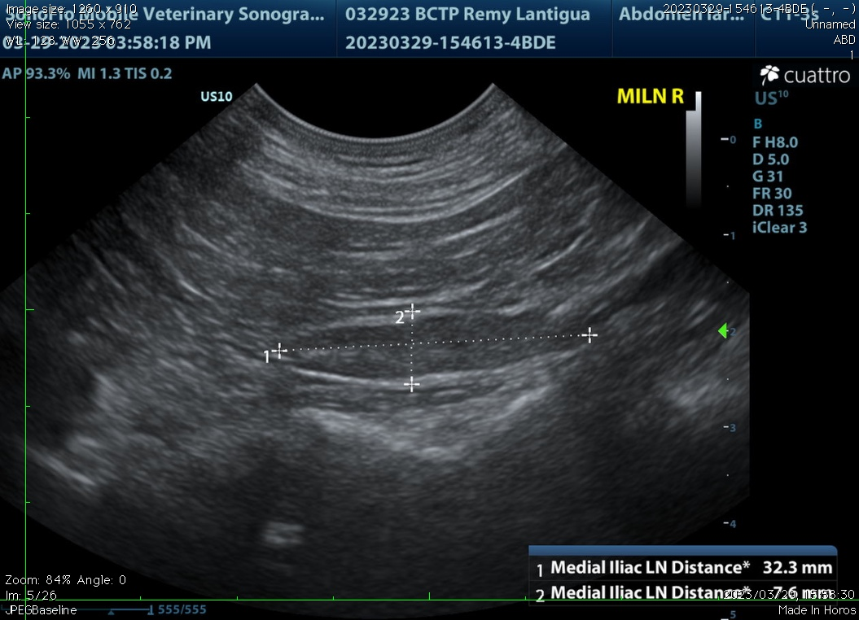
The information and recommendations provided are based on the images presented by the referring veterinarian. No evaluation can be communicated regarding pathology that was not visible in the image/video clips provided.

Thank you for this referral. If the clinical or image interpretation does not parallel your findings or if I can be of any further assistance, please contact me.

Remo Lobetti, BVSc, MMedVet (Med), PhD, Dipl. ECVIM (Internal Medicine)
rlobetti@mweb.co.za

